Lakeflow Spark Declarative Pipelines
Hotel Booking Analytics Platform

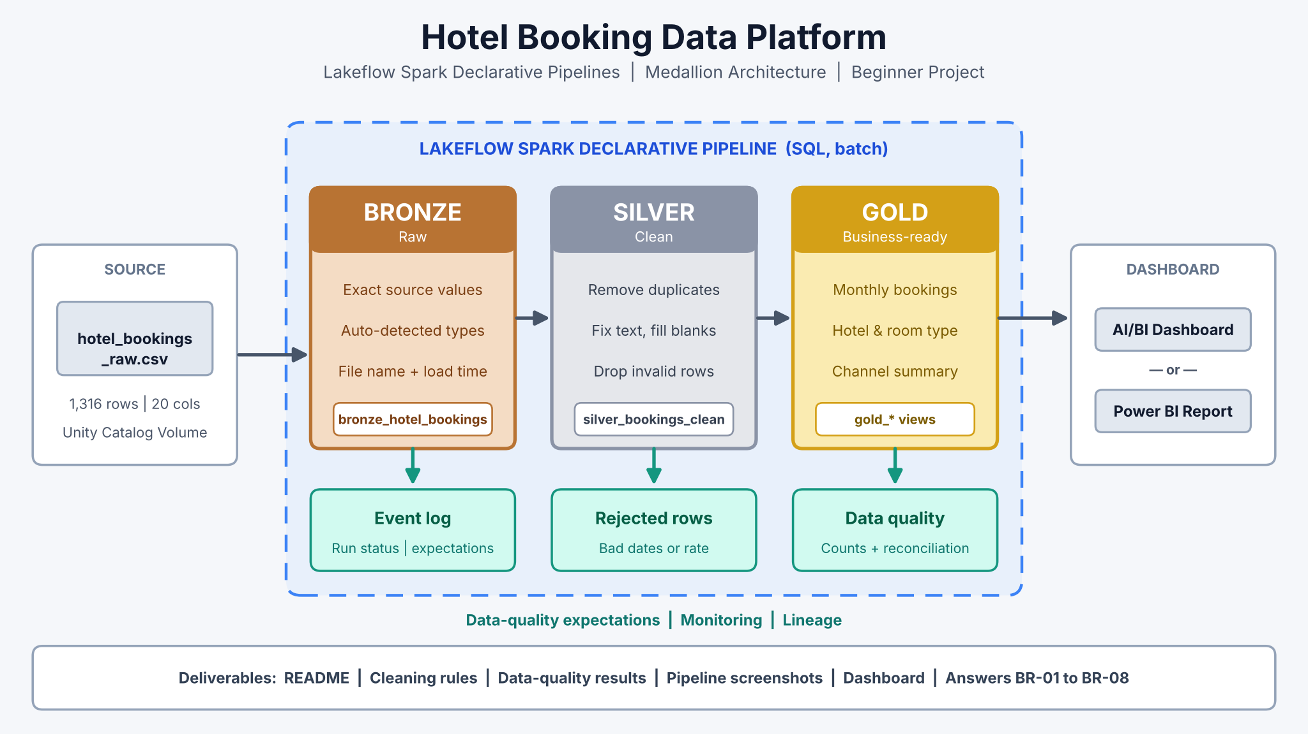
Project level: Beginner • Estimated time: 6–8 hours • SQL you need: SELECT, WHERE, GROUP BY, COUNT, SUM, AVG, DISTINCT, TRIM, INITCAP, COALESCE, CASE WHEN, DATEDIFF.

1. Executive Summary
A hotel group exports all its room bookings to a CSV file. Managers want simple, reliable reports on bookings, revenue, room nights, hotels, room types and booking channels, including how many bookings are cancelled. The file has common problems: extra spaces, inconsistent capital letters, blank values, duplicate bookings, impossible stay dates and a few negative room rates. You will build a Databricks Medallion Architecture that keeps the raw file, cleans it step by step, creates business-ready summary tables, and shows them in a dashboard.
Project goal: Transform a raw hotel bookings CSV into trusted Gold-layer tables using Databricks SQL and Lakeflow Spark Declarative Pipelines, then build one dashboard on top of them.

2. Business Background
The hotel group owns ten hotels in seven Indian cities, including Goa, Jaipur, Udaipur, Kochi, Shimla, Mumbai and Bengaluru. Guests book a Standard, Deluxe, Suite or Family Room through the Website, the Mobile App, a Travel Agent or as a Walk In. Each booking has a check-in date, a check-out date, a number of nights, a room rate, a discount and a meal plan. Some bookings are completed and some are cancelled. Only completed stays earn revenue.

Current business challenges
- City, room type, booking channel and meal plan values have extra spaces and mixed capital letters.
- Some bookings are missing the city, booking channel, guest ID, number of nights or total amount.
- Some bookings appear twice, which makes bookings and revenue look bigger than they are.
- A few bookings have a check-out date on or before the check-in date, or a negative room rate.
- Reports mix up cancelled and completed bookings, so revenue numbers are not trusted.

3. Business Problem and Objectives
The hotel group has no automatic way to turn the raw bookings file into numbers it can trust. This project builds a repeatable pipeline that keeps the original file, cleans the data, prepares summary tables and shows them in a dashboard.

Project objectives
- Load the bookings CSV into Databricks from a Unity Catalog Volume.
- Keep the raw data in a Bronze table.
- Clean the data in a Silver table and keep the bad bookings in a separate rejected table.
- Create Gold summary tables for monthly bookings, hotels, room types and booking channels.
- Count the data problems and check that no row was lost.
- Build one dashboard in Databricks AI/BI or Power BI.

4. Dataset Overview
The learning dataset hotel_bookings_raw.csv is synthetic (made up for this project). It has 1,316 rows and 20 columns covering hotel stays in 2025. It looks like a real hotel booking export but contains no real guest data.
Hotel Bookings Dataset :- Click Here to Download Hotel Bookings Dataset
Dataset attribute | Description | Why it matters
Grain | One row = one booking. booking_id is unique for each real booking. | Tells you how to count bookings and find duplicates
Date fields | booking_date, check_in_date, check_out_date, nights | Supports monthly analysis and date checks
Hotel fields | hotel_name, city, region, room_type, meal_plan | Supports hotel, city and room-type reports
Booking fields | guest_id, booking_channel, guests, booking_status, guest_rating | Supports channel, cancellation and rating reports
Money fields | room_rate, total_amount, discount_amount, payment_method, payment_status | Supports revenue reports
Planted problems | Extra spaces, mixed case, blanks, duplicate bookings, check-out before check-in, negative rate | Gives you real cleaning practice

Column dictionary
Column | Example | Description
booking_id | BK300001 | Unique ID of one booking
guest_id | GU5321 | Guest who booked (sometimes blank)
booking_date | 2025-04-02 | Date the booking was made
check_in_date | 2025-04-20 | Arrival date
check_out_date | 2025-04-23 | Departure date
nights | 3 | Number of nights (sometimes blank)
hotel_name | Sea Breeze Resort | Name of the hotel
city | Goa | Hotel city (sometimes blank or messy)
region | West | North, South or West
room_type | Deluxe | Standard, Deluxe, Suite, Family Room (sometimes messy)
booking_channel | Mobile App | Website, Mobile App, Travel Agent, Walk In (sometimes blank or messy)
guests | 2 | Number of guests
room_rate | 5200.00 | Price per night in ₹
total_amount | 15600.00 | nights × room_rate (sometimes blank)
discount_amount | 780.00 | Discount given
meal_plan | Breakfast | Room Only, Breakfast, Half Board (sometimes messy)
payment_method | UPI | UPI, Card, Cash, Net Banking
payment_status | Paid | Paid, Pending or Refunded
booking_status | Completed | Completed or Cancelled
guest_rating | 4 | Rating 1–5 (blank for cancelled stays)

Key business formulas
- nights = DATEDIFF(check_out_date, check_in_date)
- total_amount = nights × room_rate
- net_revenue = total_amount − discount_amount (Completed bookings only)
- room_nights = SUM of nights (Completed bookings only)
- avg_daily_rate (ADR) = net_revenue ÷ room_nights

Important: booking_id should be unique. If the same booking_id appears more than once, the extra rows are duplicates. Cancelled bookings are NOT bad data: keep them in Silver, but do not count them as revenue in Gold.

5. Key Terms for Beginners
Term | Simple meaning
Unity Catalog Volume | A folder inside Databricks where you upload files such as CSVs.
Medallion Architecture | Organising data in three layers: Bronze (raw), Silver (clean), Gold (summaries).
Lakeflow Spark Declarative Pipelines | A Databricks feature where you write SQL that says what each table should contain; Databricks works out the order and runs it.
Streaming table | A table that reads new files incrementally. We use it for Bronze.
Materialized view | A saved query result that the pipeline keeps up to date. We use it for Silver and Gold.
Expectation | A data-quality rule, e.g. check_out_date > check_in_date. With ON VIOLATION DROP ROW, bad rows are removed and counted.
DATEDIFF(end, start) | Returns the number of days between two dates. DATEDIFF('2025-04-23', '2025-04-20') = 3.
Room night | One room occupied for one night. A 3-night stay = 3 room nights.
Reconciliation | Checking that every input row is accounted for: kept, rejected or removed as a duplicate.

6. Proposed Architecture and Data Flow
Bronze keeps the raw bookings. Silver cleans them: good bookings (completed and cancelled) go to silver_bookings_clean and bad bookings go to silver_bookings_rejected. Gold builds summary tables from the clean bookings only, plus one data-quality table.
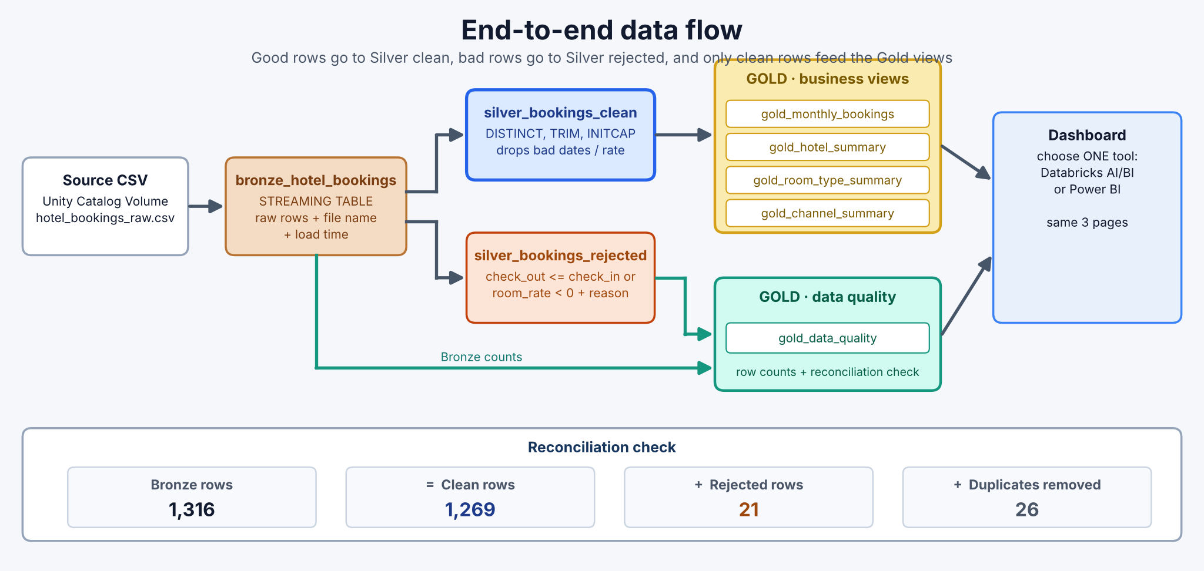
Figure 1 – End-to-end data flow and reconciliation check

7. Medallion Layer Responsibilities
Layer | Purpose | What you do | Result
Bronze | Keep the source data | Load the CSV as it is; add file name and load time | 1 raw table
Silver | Clean the data | Remove duplicates, fix text, fill blanks, drop impossible bookings (and keep them in a rejected table) | 1 clean table + 1 rejected table
Gold | Answer business questions | GROUP BY month, hotel, room type and channel; count only Completed bookings as revenue; count data problems | 5 summary tables
Dashboard | Show the results | Build 3 pages in Databricks AI/BI or Power BI | 1 dashboard

8. Business Requirements
ID | Requirement | Business expectation
BR-01 | Monthly trends | Show bookings, cancelled bookings, room nights and net revenue for each stay month.
BR-02 | Hotel performance | Compare bookings, room nights, net revenue and average daily rate by region, city and hotel.
BR-03 | Room type performance | Compare bookings, room nights, net revenue and average guest rating by room type.
BR-04 | Channel analysis | Compare bookings, cancelled bookings, cancellation rate and net revenue by booking channel.
BR-05 | Data-quality visibility | Show how many rows had each problem (duplicates, bad dates, bad rate, blanks).
BR-06 | Reconciliation | Prove that Bronze rows = clean rows + rejected rows + duplicates removed.
BR-07 | Repeatability | Run everything as a Databricks pipeline that can be re-run with one click.
BR-08 | Dashboard | Build one dashboard (Databricks AI/BI or Power BI) on the Gold tables.

9. Data Cleaning Rules
Silver cleaning is done in four simple steps. Each step uses one SQL idea.
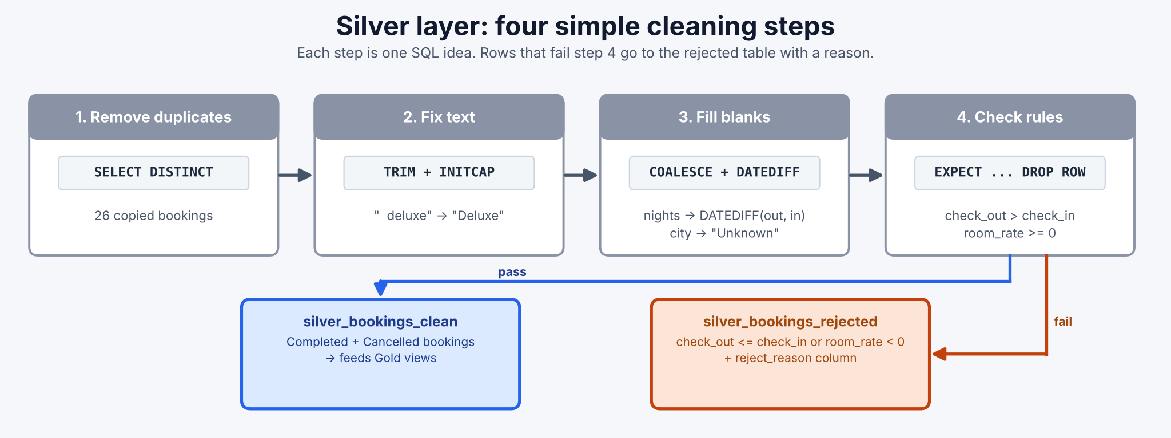
Figure 2 – The four Silver cleaning steps
Problem | Example | What to do | SQL hint
Duplicate bookings | Same booking_id appears twice | Keep only one copy | SELECT DISTINCT
Extra spaces / mixed case | " goa", "DELUXE", " mobile app " | Remove spaces, use Title Case | INITCAP(TRIM(col))
Blank city or channel | city is empty | Replace with "Unknown" | COALESCE(col, 'Unknown')
Blank nights | nights is empty | Calculate from the dates | COALESCE(nights, DATEDIFF(check_out_date, check_in_date))
Blank total amount | total_amount is empty | Calculate nights × room_rate | COALESCE(total_amount, DATEDIFF(...) * room_rate)
Blank rating or guest ID | guest_rating is empty | Keep the row and leave it blank (AVG skips blanks) | No change
Impossible dates or rate | check_out on/before check_in; room_rate = -4500 | Remove from clean table, keep in rejected table | EXPECT (check_out_date > check_in_date) ON VIOLATION DROP ROW

Watch out: A Cancelled booking is a normal business event, not a data error. Keep it in Silver. In Gold, count revenue and room nights only when booking_status = 'Completed'.

10. Project Scope

Included
- One synthetic hotel bookings CSV file.
- Batch loading from a Unity Catalog Volume.
- Bronze, Silver and Gold tables in one Lakeflow pipeline written in SQL.
- Simple data-quality checks and a reconciliation check.
- One dashboard in Databricks AI/BI or Power BI.

Not included
- Live room availability or real-time bookings.
- Occupancy rate (needs total rooms per hotel), dynamic pricing or more than one source system.
- Real guest data and privacy controls.
- Advanced data modelling (dimensions, SCD) and production alerting.

Scope note This is a learning project. Keep it simple, make it work end to end, and explain your choices.

11. Implementation Workflow
01 • Understand | Read the business questions and the 20 columns. Open the CSV and spot the problems yourself.
02 • Prepare | Create a catalog, schema and Volume. Upload the CSV.
03 • Ingest | Create the Bronze streaming table and check that 1,316 rows were loaded.
04 • Clean | Create the Silver clean and rejected tables using the four cleaning steps.
05 • Curate | Create the four Gold business tables with GROUP BY and CASE WHEN.
06 • Validate | Create the Gold data-quality table and check the reconciliation.
07 • Publish & Visualize | Build one dashboard: Databricks AI/BI or Power BI.
08 • Explain | Present your pipeline, cleaning rules, results and dashboard.

Step-by-step guide with SQL hints
Use these starter snippets. Replace or complete the parts marked with "...".

Step 02 – Prepare the storage
CREATE CATALOG IF NOT EXISTS hospitality_catalog; -- or use a catalog you already have
CREATE SCHEMA IF NOT EXISTS hospitality_catalog.bookings;
CREATE VOLUME IF NOT EXISTS hospitality_catalog.bookings.raw_files;

-- Upload hotel_bookings_raw.csv into the volume (Catalog Explorer → raw_files → Upload)
-- Then preview it:
SELECT * FROM read_files('/Volumes/hospitality_catalog/bookings/raw_files/',
format => 'csv', header => true) LIMIT 10;

Step 03 – Create the pipeline and the Bronze table
Create a new ETL pipeline (Lakeflow Spark Declarative Pipelines), set the default catalog to hospitality_catalog and schema to bookings, and add a SQL file with:
CREATE OR REFRESH STREAMING TABLE bronze_hotel_bookings AS
SELECT *,
_metadata.file_name AS source_file,
current_timestamp() AS loaded_at
FROM STREAM read_files('/Volumes/hospitality_catalog/bookings/raw_files/',
format => 'csv', header => true);

Step 04 – Silver clean and rejected tables
CREATE OR REFRESH MATERIALIZED VIEW silver_bookings_clean (
CONSTRAINT valid_stay_dates EXPECT (check_out_date > check_in_date) ON VIOLATION DROP ROW,
CONSTRAINT valid_room_rate EXPECT (room_rate >= 0) ON VIOLATION DROP ROW
) AS
SELECT DISTINCT
booking_id, guest_id, check_in_date, check_out_date,
COALESCE(nights, DATEDIFF(check_out_date, check_in_date)) AS nights,
COALESCE(INITCAP(TRIM(city)), 'Unknown') AS city,
INITCAP(TRIM(room_type)) AS room_type,
COALESCE(total_amount,
DATEDIFF(check_out_date, check_in_date) * room_rate) AS total_amount,
booking_status,
... -- add the other columns; clean booking_channel and meal_plan the same way
FROM bronze_hotel_bookings;

CREATE OR REFRESH MATERIALIZED VIEW silver_bookings_rejected AS
SELECT *,
CASE WHEN check_out_date <= check_in_date THEN 'Check-out is not after check-in'
ELSE 'Room rate is negative' END AS reject_reason
FROM bronze_hotel_bookings
WHERE check_out_date <= check_in_date OR room_rate < 0;

Step 05 – Gold business tables
CREATE OR REFRESH MATERIALIZED VIEW gold_monthly_bookings AS
SELECT DATE_TRUNC('MONTH', check_in_date) AS stay_month,
COUNT(*) AS bookings,
SUM(CASE WHEN booking_status = 'Cancelled' THEN 1 ELSE 0 END) AS cancelled_bookings,
SUM(CASE WHEN booking_status = 'Completed' THEN nights ELSE 0 END) AS room_nights,
SUM(CASE WHEN booking_status = 'Completed'
THEN total_amount - discount_amount ELSE 0 END) AS net_revenue
FROM silver_bookings_clean
GROUP BY DATE_TRUNC('MONTH', check_in_date);

Build the other three Gold tables with the same pattern:
Gold table | GROUP BY | Columns to calculate
gold_hotel_summary | region, city, hotel_name | bookings, room_nights, net_revenue, avg_daily_rate (net_revenue ÷ room_nights)
gold_room_type_summary | room_type | bookings, room_nights, net_revenue, avg_rating (AVG of guest_rating)
gold_channel_summary | booking_channel | bookings, cancelled_bookings, cancellation_rate_pct (cancelled × 100.0 ÷ bookings), net_revenue

Step 06 – Data quality and reconciliation
CREATE OR REFRESH MATERIALIZED VIEW gold_data_quality AS
SELECT COUNT(*) AS bronze_rows,
COUNT(*) - COUNT(DISTINCT booking_id) AS duplicate_rows,
SUM(CASE WHEN check_out_date <= check_in_date THEN 1 ELSE 0 END) AS invalid_date_rows,
SUM(CASE WHEN city IS NULL THEN 1 ELSE 0 END) AS missing_city_rows,
... -- add negative rate, missing channel, missing amount, missing nights
(SELECT COUNT(*) FROM silver_bookings_clean) AS clean_rows,
(SELECT COUNT(*) FROM silver_bookings_rejected) AS rejected_rows
FROM bronze_hotel_bookings;

Then run the pipeline (Start), open the pipeline graph, and check: bronze_rows = clean_rows + rejected_rows + duplicate_rows.

12. Dashboard (Choose Databricks AI/BI or Power BI)
The dashboard is the last stage of the project. It reads only the Gold tables. Build it in one tool only: Option A or Option B. Both give the same three pages.
Choose one option: If you build the dashboard in Power BI, skip Option A. If you build it as a Databricks AI/BI dashboard, skip Option B.

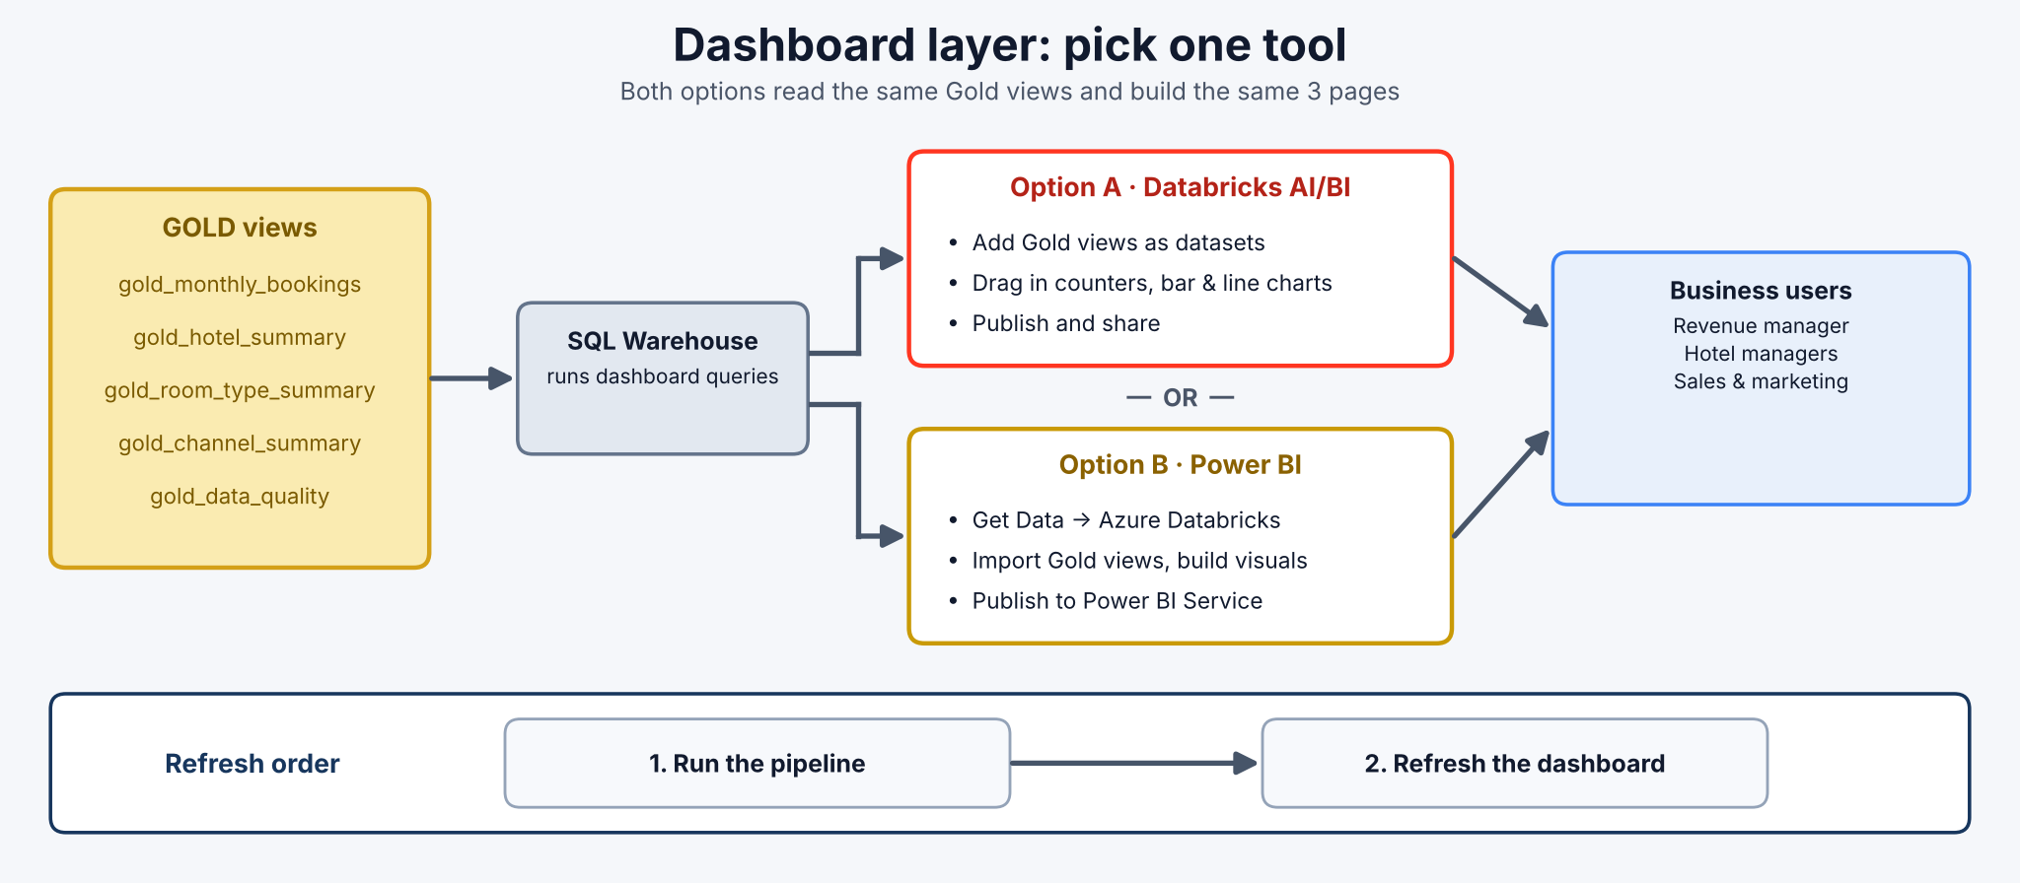
Figure 3 – Dashboard layer: one tool, same Gold tables

Dashboard pages (same for both options)
Page | Visuals | Gold table
1. Overview | KPI cards: Total Bookings, Net Revenue, Room Nights, Cancelled Bookings; line chart of net revenue by stay month; bar chart of net revenue by city | gold_monthly_bookings, gold_hotel_summary
2. Hotels, Rooms & Channels | Bar chart of net revenue by hotel; table of hotels with average daily rate; bar chart of revenue and average rating by room type; bar chart of cancellation rate by channel | gold_hotel_summary, gold_room_type_summary, gold_channel_summary
3. Data Quality | Cards: Bronze rows, clean bookings, rejected rows, duplicates; reconciliation passed (Yes/No); bar chart of problem counts | gold_data_quality

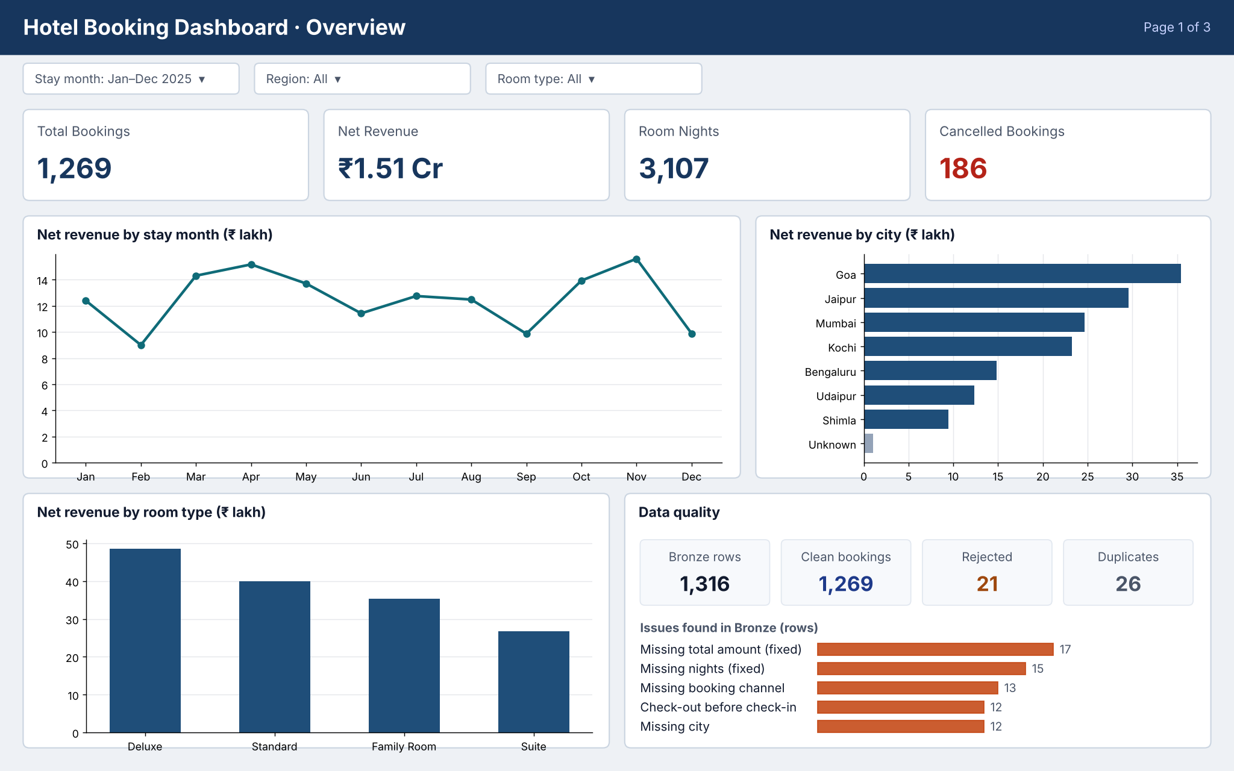
Figure 4 – Example Overview page (numbers from the reference solution)

Option A – Databricks AI/BI Dashboard
- Create: in Databricks choose New → Dashboard.
- Add data: on the Data tab, add each Gold table as a dataset (pick the table or write SELECT * FROM ...).
- Add visuals: on the canvas, add Counter widgets for the KPIs (sum of bookings, net_revenue, room_nights, cancelled_bookings), a Line chart for monthly revenue and Bar charts for city, hotel, room type and channel.
- Add filters: add a filter for stay month, region or room type where those columns exist.
- Publish: click Publish and share the dashboard with your team. Optionally add a refresh schedule.

Option B – Power BI Report
- Connect: in Power BI Desktop choose Get Data → Azure Databricks. Copy the Server hostname and HTTP path from your SQL warehouse (Connection details tab) and sign in.
- Load data: open hospitality_catalog → bookings, tick the five gold_* tables, and choose Import.
- Add visuals: use Card visuals for the KPIs (Sum of bookings, net_revenue, room_nights, cancelled_bookings), a Line chart for monthly revenue and Bar charts for city, hotel, room type and channel.
- Rates and ratings: show avg_daily_rate, avg_rating and cancellation_rate_pct per hotel, room type or channel in tables or bar charts (do not add up or average these values).
- Add filters: add Slicers for stay month, region or room type on the pages where those columns exist.
- Publish: click Publish to send the report to Power BI Service and share it. Optionally set a scheduled refresh.

Check your numbers: The Total Bookings card should equal the clean_rows value in gold_data_quality (1,269), and Net Revenue must not include cancelled bookings.

13. Expected Deliverables
- A pipeline with Bronze, Silver (clean + rejected) and Gold tables.
- A short list of your cleaning rules and why you chose them.
- The gold_data_quality result showing the reconciliation check passed.
- One dashboard with three pages (Databricks AI/BI or Power BI).
- A README explaining how to set up and run the project.
- Screenshots of the pipeline graph, the Gold tables and the dashboard.

14. Acceptance Criteria / Definition of Done
- The CSV loads from the Volume and Bronze has 1,316 rows.
- Silver clean has no duplicate bookings, no extra spaces, no blank city, channel, nights or amount, and no impossible dates or rates.
- Rejected bookings are saved with a reason.
- Cancelled bookings are kept in Silver but excluded from revenue and room nights in Gold.
- The four Gold business tables answer BR-01 to BR-04.
- gold_data_quality shows that bronze rows = clean + rejected + duplicates.
- The pipeline runs again with one click and the dashboard numbers match the Gold tables.

15. Questions for Project Review
- Why do we keep the raw data in Bronze instead of cleaning the file directly?
- Why is a cancelled booking kept, but a booking with check-out before check-in rejected?
- Why can booking_id find duplicates but guest_id cannot?
- How does DATEDIFF fill a blank nights value, and what happens if you swap its arguments?
- Why do we leave a blank rating as NULL instead of replacing it with 0?
- What is the average daily rate (ADR), and why is it calculated as net revenue ÷ room nights?
- Which booking channel has the highest cancellation rate?
- Which dashboard tool did you choose, and why?

16. Final Business Outcome
At the end of the project, the hotel group has a repeatable pipeline that turns a messy bookings file into clean, trusted summary tables and a simple dashboard. You can explain where the data came from, what problems you found, how you fixed them, why cancelled bookings are treated differently, and how you proved the numbers are correct.
Key takeaway Medallion Architecture means each layer makes the data a little more trustworthy: Bronze keeps it, Silver cleans it, Gold summarises it, and the dashboard shares it.

